**Riverside Burger Bash Image Attributions**

Andrew Krause

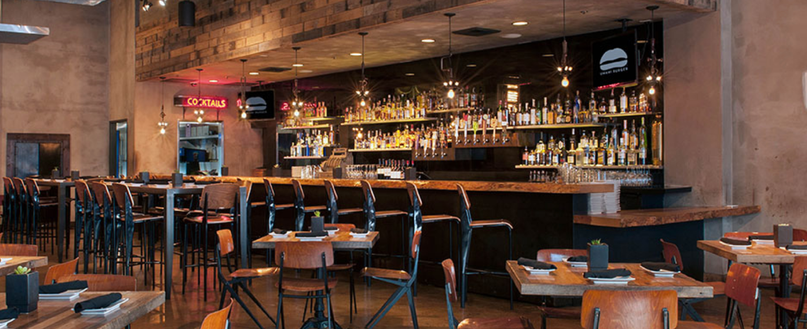

["Umami Burger | Restaurants | Ennismore"](https://www.sbe.com/sites/default/files/2019-10/umami-burger-location-broadway-new-2.jpg) by [Umami Burger](https://www.sbe.com/restaurants/umami-burger), [Umami Burger](https://www.sbe.com/restaurants/umami-burger)

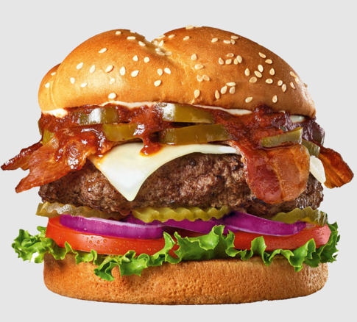

["Feel the Burn Burger"](https://theburgerden.com/wp-content/uploads/2021/06/Flamin_5_Pepper_Burger_Clipped_Sept21Core.CC.R3800x770.png) by [The Burger Den](https://theburgerden.com/menu-2/), [The Burger Den](https://theburgerden.com/menu-2/)

["Loaded A.1.® 1/3lb.* Signature Stackburger"](https://www.dairyqueen.com/dA/991ecdf411/DQ-Stackburger-Loaded-A1-Double-US.png) by [Dairy Queen](https://www.dairyqueen.com/en-us/menu/loaded-a1-stackburger/), [Dairy Queen](https://www.dairyqueen.com/en-us/menu/loaded-a1-stackburger/)

["Double the Fun Burger"](https://theburgerden.com/wp-content/uploads/2021/09/Americas_Diner_Burger_Clipped_Sept21Core.CC.R3.png) by [The Burger Den](https://theburgerden.com/menu-2/), [The Burger Den](https://theburgerden.com/menu-2/)

["FlameThrower Signature Stackburgers"](https://dairyqueen-prod.dotcdn.io/dA/768c2de055/fileAsset/FlamethrowerCDADuo.png) by [Dairy Queen](https://www.dairyqueen.com/en-us/menu/flamethrower-stackburger/), [Dairy Queen](https://www.dairyqueen.com/en-us/menu/flamethrower-stackburger/)

["1/3 Double with Cheese- Sandwich"](https://www.dairyqueen.com/dA/8b2418ed10/third-pound-double-cheeseburger.png) by [Dairy Queen](https://www.dairyqueen.com/en-ca/menu/1-3-lb-double-w-cheese/), [Dairy Queen](https://www.dairyqueen.com/en-ca/menu/1-3-lb-double-w-cheese/)

["McDonald’s French Fries – Copycat Recipe"](https://www.google.com/search?q=images+of+french+fries+the+cozy+cook&sxsrf=ALiCzsbkxBT7dZYkCMdwXzzouXqQY1SKwA:1672793621217&source=lnms&tbm=isch&sa=X&ved=2ahUKEwiZwMzs2az8AhVclWoFHf-dBs4Q_AUoAXoECAEQAw&biw=1568&bih=871&dpr=2#imgrc=PLBdbKo8ri9kzM) by [The Cozy Cook](https://thecozycook.com/mcdonalds-french-fries/), [The Cozy Cook](https://thecozycook.com/mcdonalds-french-fries/)

["Air-Fried Jalapeño Poppers"](https://www.google.com/search?q=images+of+jalapeno+poppers+myrecipes&sxsrf=ALiCzsaj5iVdD3UyUAGB2tskDW-ZQKZixg:1672795504432&source=lnms&tbm=isch&sa=X&ved=2ahUKEwik9sru4Kz8AhVAlGoFHW48C9IQ_AUoAXoECAEQAw&biw=1568&bih=871&dpr=2#imgrc=gXgvvJcExAn8yM) by [MyRecipes](https://www.myrecipes.com/recipe/air-fried-jalapeno-poppers), [MyRecipes](https://www.myrecipes.com/recipe/air-fried-jalapeno-poppers)

["Jessica's Coleslaw"](https://www.google.com/search?q=images+of+eatingWell+coleslae&oq=images+of+eatingWell+coleslae&aqs=chrome..69i57j33i10i160l3.4473j0j4&sourceid=chrome&ie=UTF-8#imgrc=jRec6XvX06e4jM) by [EatingWell](https://www.eatingwell.com/recipe/280654/jessicas-coleslaw/), [EatingWell](https://www.eatingwell.com/recipe/280654/jessicas-coleslaw/)

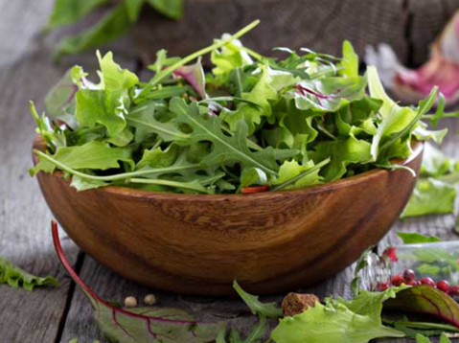

["9 GOOD REASONS TO EAT A SALAD A DAY"](https://www.google.com/search?q=images+of+food+salad+9+good+reasons+to+eat+salad+every+day&tbm=isch&ved=2ahUKEwjxlZGJwq78AhV8Fd4AHethBE8Q2-cCegQIABAA&oq=images+of+food+salad+9+good+reasons+to+eat+salad+every+day&gs_lcp=CgNpbWcQA1CxA1jpLWCOL2gAcAB4AYABuQGIAbUWkgEEMzguMZgBAKABAaoBC2d3cy13aXotaW1nwAEB&sclient=img&ei=lsG1Y_HyBPyq-LYP68OR-AQ&bih=871&biw=1525#imgrc=Lo4uyws0QWJLEM) by [FOODAL](https://foodal.com/knowledge/paleo/9-good-reasons-to-eat-a-salad-a-day/), [FOODAL](https://foodal.com/knowledge/paleo/9-good-reasons-to-eat-a-salad-a-day/)

["Mint Chip Milk Shake"](https://www.google.com/search?q=images+of+mint+milkshake+very+best+baking&sxsrf=AJOqlzVrFDpR-J-6rwCsNShI5gxpYZwjqQ:1672856272602&source=lnms&tbm=isch&sa=X&ved=2ahUKEwiT3Y2fw678AhWXBzQIHbcoDpAQ_AUoAXoECAEQAw&biw=1525&bih=871&dpr=2#imgrc=-79ltJvxEuIWGM) by [Very Best Baking](https://www.verybestbaking.com/toll-house/recipes/mint-chip-milk-shake/), [Very Best Baking](https://www.verybestbaking.com/toll-house/recipes/mint-chip-milk-shake/)

["How to Make a Margarita"](https://www.google.com/search?q=images+of+how+to+make+a+margarita+baking+a+moment&sxsrf=ALiCzsZnib8vDTe5HSEpA0qB7GaPrL9C6g%3A1672856597661&ei=FcS1Y_WCKOKvqtsPye224AU&ved=0ahUKEwi14Y26xK78AhXil2oFHcm2DVwQ4dUDCBA&uact=5&oq=images+of+how+to+make+a+margarita+baking+a+moment&gs_lcp=Cgxnd3Mtd2l6LXNlcnAQAzIFCCEQoAEyBQghEKABOgoIABBHENYEELADOggIIRAWEB4QHToFCCEQqwJKBAhBGABKBAhGGABQ7wJYng9g4w9oAXABeACAAYYBiAG9DJIBBDQuMTGYAQCgAQHIAQjAAQE&sclient=gws-wiz-serp#imgrc=Lt2xfxIneHv0_M) by [Baking a Moment](https://bakingamoment.com/how-to-make-a-margarita/), [Baking a Moment](https://bakingamoment.com/how-to-make-a-margarita/)

["Wizz Fizz Spider"](https://www.google.com/search?q=images+of+malted+root+beer+float&sxsrf=AJOqlzVkmsyPF0-iYHzMo-7Fqbvib4kiNw%3A1672856924168&ei=XMW1Y5n1CbiF0PEPrd-o8AY&ved=0ahUKEwiZk-bVxa78AhW4AjQIHa0vCm4Q4dUDCBA&uact=5&oq=images+of+malted+root+beer+float&gs_lcp=Cgxnd3Mtd2l6LXNlcnAQAzIICCEQwwQQoAE6CggAEEcQ1gQQsAM6BQgAEKIEOgcIABAeEKIESgQIQRgASgQIRhgAUOwCWKMqYJgraANwAXgAgAF5iAGdC5IBBDEyLjSYAQCgAQHIAQfAAQE&sclient=gws-wiz-serp#imgrc=f8kiSxLcQloMBM) by [Home Beautiful](https://www.homebeautiful.com.au/wizz-fizz-spider), [Home Beautiful](https://www.homebeautiful.com.au/wizz-fizz-spider)

["EASY STRAWBERRY DAIQUIRI"](https://www.google.com/search?q=images+of+miss+in+the+kitdchen+daiquiri&oq=images+of+miss+in+the+kitdchen+daiquiri&aqs=chrome..69i57j33i10i160l2.11700j0j4&sourceid=chrome&ie=UTF-8#imgrc=KUhRIF-tz-HpJM) by [Miss in the Kitchen](https://www.missinthekitchen.com/easy-strawberry-daiquiri/), [Miss in the Kitchen](https://www.missinthekitchen.com/easy-strawberry-daiquiri/)

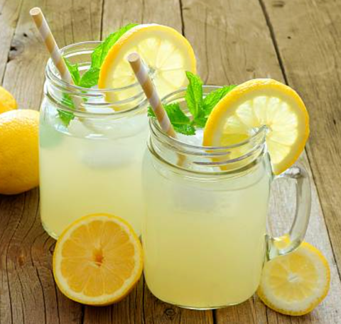

["Homemade Lemonade Recipe"](https://www.google.com/search?q=images+of+homemade+lemonade+recipe+times+food&sxsrf=ALiCzsbf-0FVoUJ4iqPfZYy2bL9dE9PhwA%3A1672857519512&ei=r8e1Y6vvHuymqtsPubWFuA4&ved=0ahUKEwjrgtfxx678AhVsk2oFHblaAecQ4dUDCBA&uact=5&oq=images+of+homemade+lemonade+recipe+times+food&gs_lcp=Cgxnd3Mtd2l6LXNlcnAQAzIFCAAQogQyBwgAEB4QogQyBQgAEKIEOgoIABBHENYEELADOgoIIRDDBBAKEKABSgQIQRgASgQIRhgAUFRYoAZgjgdoAXABeACAAYABiAGlBZIBAzQuM5gBAKABAcgBCMABAQ&sclient=gws-wiz-serp#imgrc=1_JCGk129AwtkM) by [Times Food](https://recipes.timesofindia.com/us/beverage/non-alcoholic/homemade-lemonade/rs53962071.cms), [Times Food](https://recipes.timesofindia.com/us/beverage/non-alcoholic/homemade-lemonade/rs53962071.cms)